July 01, 2014
Contact person specialized press
Frank Gmach
Communications Inorganic Materials
Phone +49 6181 59-13588
Fax +49 6181 59-713588
frank.gmach@evonik.com

Evonik Industries AG
Rellinghauser Straße 1-11
45128 Essen
Germany
Phone +49 201 177-01
Telefax +49 201 177-3475
www.evonik.de

Supervisory Board
Dr. Werner Müller, Chairman
Executive Board
Dr. Klaus Engel, Chairman
Christian Kullmann
Thomas Wessel
Patrik Wohlhauser
Ute Wolf
Registered office Essen
Registered court
Essen local court
Commercial registry B 19474
VAT ID no. DE 811160003

Evonik invests in new research center at Rheinfelden site

- Investments in double-digit-million € range
- Jobs for up to 70 highly-qualified employees
- Leading site in silane research

Essen-based Evonik Industries is making an investment in the double-digit-million euro range in a new research center at the Rheinfelden site. Starting at the beginning of 2016, research into silanes will be carried out in modern laboratories in the four-story building. Silanes are used in the electronics industry, in the tire industry, for the production of adhesives and sealants as well as plastics, and in the construction industry. Application engineering, analytics, and quality management will also be located in the new research center in the future. The center fits in perfectly with the integrated silane chemical production network in Rheinfelden, which encompasses research, development, application technology, and production.

At the ground-breaking ceremony on June 30, 2014, Johann-Caspar Gammelin, Head of the Site Services Business Unit at Evonik, said: “For Germany as a business location as well as for Evonik, the ability to create something new is of vital importance. Here in Rheinfelden we are laying the foundation stone not just for the new building, but also for further innovation and therefore advanced, efficient, custom-tailored products.”

Ralph Marquardt, Head of Innovation in the Inorganic Materials Business Unit, explained the importance of silane research: “Evonik is the global market leader for functional silanes. We make target-oriented investments to build on this position. In this context, first-class research and application engineering are a key factor for further positive development.”

The new research center will house up 70 employees at ultra-modern workstations on an area of around 3,500 m². Peter Dettelmann, head of the Rheinfelden site, explained its focus of activity as follows: “The silanes we are researching into here make chips in smartphones faster and more efficient, protect buildings from corrosion and dirt, and enable fuel-saving tires or longer-lasting paints. We are delighted to construct a building using sustainable techniques for this.”

Evonik produces silanes at its sites in Rheinfelden (Germany), Antwerp (Belgium), Rizhao (China), Mobile (USA), and Weston (USA). The specialty chemical company also operates laboratories for application technology support and regionally specialized research for silanes in China, India, Germany, and the United States. Evonik’s silane portfolio comprises chlorosilanes and organo-functional silanes with an overall annual capacity of 300,000 metric tons.

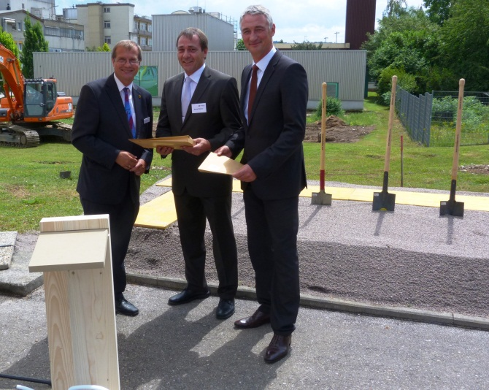

Capture:
Klaus Eberhardt, Mayor of the city of Rheinfelden, hands over the building permission to Evonik's Werner Wohner and Peter Dettelmann. (Photo: Evonik Industries AG)

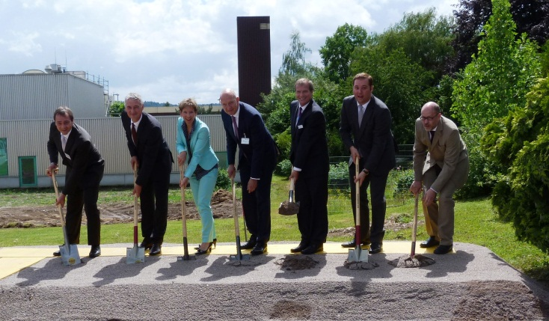

Capture:
At the groudbreaking ceremony for the new research center at the Rheinfelden site of Evonik: Werner Wohner (Evonik), Peter Dettelmann (Evonik), Marion Dammann (District Lörrach), Johann-Caspar Gammelin (Evonik), Klaus Eberhardt (City of Rheinfelden), Felix Schreiner (Landtag member Baden-Württemberg), Sven Feldmann (Evonik). (Photo: Evonik Industries AG)

About Evonik
Evonik, the creative industrial group from Germany, is one of the world leaders in specialty chemicals. Profitable growth and a sustained increase in the value of the company form the heart of Evonik’s corporate strategy. Its activities focus on the key megatrends health, nutrition, resource efficiency and globalization. Evonik benefits specifically from its innovative prowess and integrated technology platforms.

Evonik is active in over 100 countries around the world. In fiscal 2013 more than 33,500 employees generated sales of around €12.7 billion and an operating profit (adjusted EBITDA) of about €2.0 billion.

Disclaimer
In so far as forecasts or expectations are expressed in this press release or where our statements concern the future, these forecasts, expectations or statements may involve known or unknown risks and uncertainties. Actual results or developments may vary, depending on changes in the operating environment. Neither Evonik Industries AG nor its group companies assume an obligation to update the forecasts, expectations or statements contained in this release.

