October 17, 2018

Economic press contact
Edda Schulze
Phone +49 201 177-2225
Fax +49 201 177-3030
edda.schulze@evonik.com

Technical press contact
Robert Brown
Corporate Communications
Phone +1 973 929 8812
robert.brown@evonik.com

Evonik Industries AG
Rellinghauser Straße 1-11
45128 Essen
Germany
Phone +49 201 177-01
Fax +49 201 177-3475
www.evonik.com

Supervisory Board
Bernd Tönjes, Chairman
Dr. Werner Müller, Honorary Chairman
Executive Board
Christian Kullmann, Chairman
Dr. Harald Schwager, Deputy Chairman
Thomas Wessel
Ute Wolf

Registered Office is Essen
Register Court Essen Local Court
Commercial Registry B 19474

Evonik starts production of precipitated silica in South Carolina

- Growing demand for silica for tires with reduced rolling resistance to save energy
- Investment of about US$120 million creates more than 40 new jobs
- New ULTRASIL® 7800 GR customized silica for energy-saving tires for SUVs also comes from South Carolina

Evonik Industries has started up a precipitated silica plant for the tire industry in South Carolina, in southeastern USA. Evonik has invested about US$120 million in this world-scale production plant, in response to the high demand from the tire industry for precipitated silica in North America. The automotive sector needs highly dispersible precipitated silica for production of tires with improved rolling resistance and better wet grip. Silicas are part of Smart Materials, one of Evonik’s four strategic growth engines.

“The opening of the new production plant is an important step in strengthening our position as a global partner for the tire industry,” said Harald Schwager, deputy chairman of the Executive Board of Evonik Industries. “In the expansion of our silica business we’re following a clear strategy. In addition to taking over the activities of Huber Silica we’re continually expanding our capacities for silica.”

Proximity to key customers in the tire industry was the decisive factor in the choice of the South Carolina site. Johannes Ohmer, member of the Management Board of Evonik Resource Efficiency GmbH, said: “From here we plan to supply our local customers with innovative products and custom-tailored solutions.” Evonik will also produce the recently developed ULTRASIL® 7800 GR silica in South Carolina. Due to its larger specific surface area, ULTRASIL® 7800 GR gives the tread compound more rigidity without negatively impacting its processability. It is therefore particularly suitable for SUVs, whose main global market is the US.

The construction of the new production plant in Charleston creates over 40 new jobs.

Evonik is a leading global manufacturer of silica. In addition to the fumed silica AEROSIL® and the precipitated silica ULTRASIL®, SIPERNAT®, ZEODENT® and SPHERILEX®, Evonik also produces silica-based matting agents under the ACEMATT® brand name and other fumed metal oxides under the brand AEROXIDE®. Overall, Evonik has a global production capacity for all silica-based products of about 1 million metric tons/year.
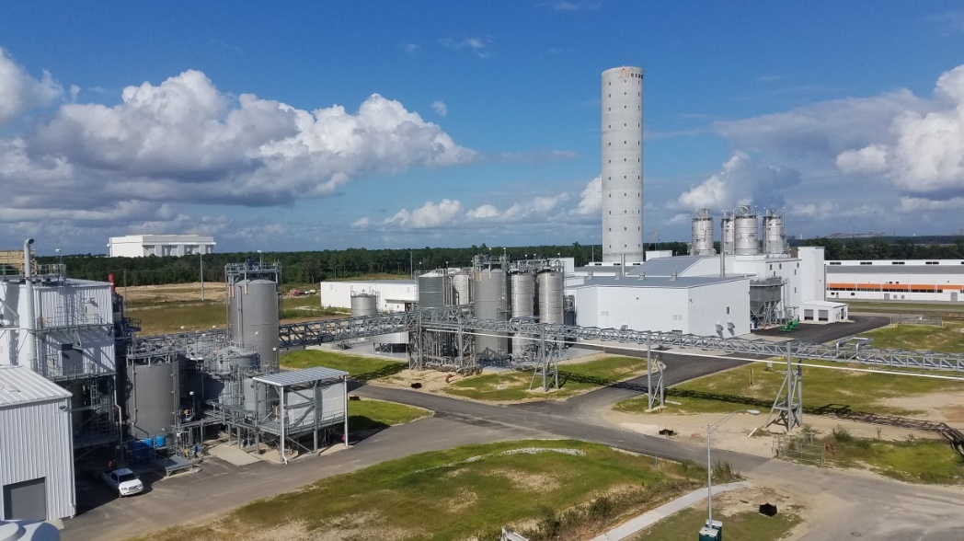

Evonik starts the production of precipitated silica in the U.S. state of South Carolina to supply the tire industry.

ULTRASIL® 7800 GR by Evonik is a tailor-made silica for extra-large SUV tires, as well as for heavily used all-season tires.

About Evonik
Evonik is one of the world leaders in specialty chemicals. The focus on more specialty businesses, customer-orientated innovative prowess and a trustful and performance-oriented corporate culture form the heart of Evonik’s corporate strategy. They are the lever for profitable growth and a sustained increase in the value of the company. Evonik benefits specifically from its customer proximity and leading market positions. Evonik is active in over 100 countries around the world with more than 36,000 employees. In fiscal 2017, the enterprise generated sales of €14.4 billion and an operating profit (adjusted EBITDA) of €2.36 billion.

About Resource Efficiency
The Resource Efficiency segment is led by Evonik Resource Efficiency GmbH and produces high performance materials and specialty additives for environmentally friendly as well as energy-efficient systems to the automotive, paints & coatings, adhesives, construction, and many other industries. This segment employed about 10,000 employees, and generated sales of around €5.4 billion in 2017.

Disclaimer
In so far as forecasts or expectations are expressed in this press release or where our statements concern the future, these forecasts, expectations or statements may involve known or unknown risks and uncertainties. Actual results or developments may vary, depending on changes in the operating environment. Neither Evonik Industries AG nor its group companies assume an obligation to update the forecasts, expectations or statements contained in this release.

