March 18, 2013

Contact for Technical Press

Dr. Jürgen Krauter
Communication, Health & Nutrition
Phone +49 6181 59-6847
Fax +49 6181 59-76847
juergen.krauter@evonik.com
Evonik Industries AG
Rellinghauser Straße 1-11
45128 Essen
Phone +49 201 177-01
Fax +49 201 1773475
www.evonik.de

Supervisory Board
Dr. Werner Müller, Chairman
Executive Board
Dr. Klaus Engel, Chairman
Dr. Wolfgang Colberg,
Dr. Thomas Haeberle, Thomas Wessel,
Patrik Wohlhauser, Dr. Dahai Yu

Registered Office: Essen
Register Court:
Essen Local Court
Commercial Registry B 19474
Sales Tax ID number: DE 811160003
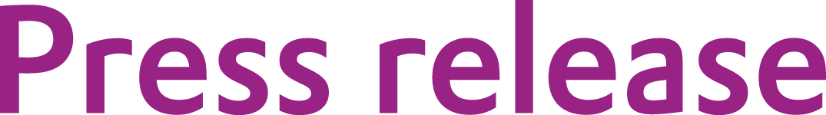
Evonik expands production capacity for Mepron®

Evonik Industries expands its production capacity for Mepron®, a coated DL-methionine product for dairy cows, by one third by mid-2013. Evonik is taking this step to further solidify its strong position in the market of rumen-protected methionine products.

“We have been successfully active in this market for over twenty years and this investment affirms our long-term strategy in the area of feed additives," said Dr. Reiner Beste, head of the Health & Nutrition Business Unit at Evonik.

High-performing dairy cows have a particularly high demand for methionine, which is typically covered by feed protein. However, high prices for feed protein, the increasing performance of dairy cows, and scientific insights from animal nutrition research with respect to the amino acid demand of high-performing dairy cows have contributed to a continuous rise in demand for methionine products for dairy cows over the past years.

"Adding Mepron® to a dairy cow ration allows the crude protein content in the diet to be reduced without any loss in performance," explains Dr. Beste. This cuts down on the overall cost of feed while increasing the profitability of dairy operations.

Evonik is the only company worldwide to produce and market all four essential amino acids for modern animal nutrition: Biolys® (source of L-lysine), MetAMINO® (DL-methionine), ThreAMINO® (L-threonine), and TrypAMINO® (L-tryptophan). The Group provides innovative services and products in more than 100 countries.

Company information
Evonik, the creative industrial group from Germany, is one of the world leaders
in specialty chemicals. Profitable growth and a sustained increase in the value of the company form the heart of Evonik’s corporate strategy. Its activities focus on the key megatrends health, nutrition, resource efficiency and globalization. Evonik benefits specifically from its innovative prowess and integrated technology platforms.

Evonik is active in over 100 countries around the world. In fiscal 2012 more than 33,000 employees generated sales of around €13.6 billion and an operating profit (adjusted EBITDA) of about €2.6 billion.

Disclaimer
In so far as forecasts or expectations are expressed in this press release or where our statements concern the future, these forecasts, expectations or statements may involve known or unknown risks and uncertainties. Actual results or developments may vary, depending on changes in the operating environment. Neither Evonik Industries AG nor its group companies assume an obligation to update the forecasts, expectations or statements contained in this release.

