February 23, 2015
Contact person economic press
Dr. Edda Schulze
Corporate Press
Phone +49 201 177-2555
Fax +49 201 177-3030
edda.schulze@evonik.com
Contact person Specialized Press
Dr. Karin Aßmann
Innovation Networks & Communication
Phone +49 6181 59-12230
Fax +49 6181 59-712230
karin.assmann@evonik.com

Evonik Industries AG
Rellinghauser Straße 1-11
45128 Essen
Germany
Phone +49 201 177-01
Telefax +49 201 177-3475
www.evonik.com

Supervisory Board
Dr. Werner Müller, Chairman
Executive Board
Dr. Klaus Engel, Chairman
Christian Kullmann
Thomas Wessel
Patrik Wohlhauser
Ute Wolf

Registered office Essen
Registered court
Essen local court
Commercial registry B 19474
VAT ID no. DE 811160003

Evonik markets specialty amine for more efficient acid gas scrubbing

- First market successes achieved with biogas – successful introduction to natural gas market
- CAPLUS® reduces energy consumption and increases capacity in industrial gas stream scrubbing

After its success with biogas upgrading, Evonik Industries has now entered the significant market for natural gas purification. Natural gas is the most important gas stream worldwide. The International Energy Agency estimates that gas consumption will increase by approximately 50 percent by the year 2035 to make up a quarter of the world’s energy mix. In CAPLUS®, the specialty chemicals company has introduced a new class of amines for scrubbing industrial gas streams onto the market. Without being scrubbed, gas streams such as natural gas, biogas, synthesis gas and flue gas are hardly useable. CAPLUS® removes unwanted acid gases such as carbon dioxide and hydrogen sulfide much more effectively than conventional amines and, at the same time, also increases the performance and working life of plants. With CAPLUS®, unpleasant side-effects such as foaming, decomposition, corrosion and intense energy consumption can be avoided.

CAPLUS® is currently being introduced to renowned natural-gas producers in Southeast Asia, the Middle East/North Africa and South America. “Our biggest challenge was convincing the first big natural-gas company to convert to CAPLUS®,” says Dr. Jörn Rolker, Project Manager at Evonik Industries. “We have positioned ourselves as a complete technology supplier with an intense focus on the customer's plant and a comprehensive package of services. And it has won customers over.”

In July 2014, a large, commercial natural-gas processing plant in Southeast Asia was filled with CAPLUS®. “During the nearly three-month observation period, CAPLUS® confirmed all predicted and contractually agreed added value,” says Rick Steglich, Director of Innovation. Due to the excellent performance of the product, the customer wants to convert other plants to CAPLUS® in the future.

Around two years ago, CAPLUS was filled into a commercial biogas plant for the first time. Despite the extreme conditions, no refilling of the absorbent was necessary the whole time. Compared with conventional absorption agents available on the market, it allows energy savings of approximately 10 percent and capacity increases of approximately 20 percent to be obtained.

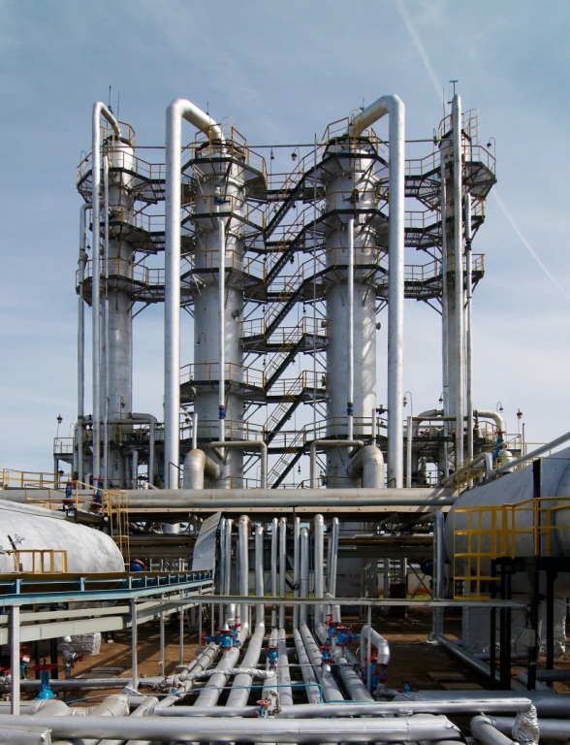

Capture: Typical commercial gas plant in which CAPLUS® is used for acid gas scrubbing (Source: Gulnaz Yaminova)

Company information
Evonik, the creative industrial group from Germany, is one of the world leaders
in specialty chemicals. Profitable growth and a sustained increase in the value of the company form the heart of Evonik’s corporate strategy. Its activities focus on the key megatrends health, nutrition, resource efficiency and globalization. Evonik benefits specifically from its innovative prowess and integrated technology platforms.

Evonik is active in over 100 countries around the world. In fiscal 2013 more than 33,500 employees generated sales of around €12.7 billion and an operating profit (adjusted EBITDA) of about €2.0 billion.

Disclaimer
In so far as forecasts or expectations are expressed in this press release or where our statements concern the future, these forecasts, expectations or statements may involve known or unknown risks and uncertainties. Actual results or developments may vary, depending on changes in the operating environment. Neither Evonik Industries AG nor its group companies assume an obligation to update the forecasts, expectations or statements contained in this release.

