April 26, 2016

Specialized Press Contact
Janusz Berger
High Performance Polymers
Phone 49 2365 49-9227
Fax +49 2365 49-809878
janusz.berger@evonik.com

Evonik Resource Efficiency GmbH
Rellinghauser Strasse 1-11
45128 Essen
Germany
Phone +49 201 177-01
Fax +49 201 177-3475
www.evonik.com

Supervisory Board
Dr. Ralph Sven Kaufmann, Chairman
Management Board
Dr. Claus Rettig, Chairman
Dr. Johannes Ohmer,
Simone Hildmann,
Alexandra Schwarz

Registered Office: Essen
Register Court: Essen Local Court
Commercial Registry B 25783
VAT ID no. DE 815528487
Evonik’s special rings

Evonik Industries presents its product range of C₈ chemicals. The specialty chemicals company is a leader in the production of industrially available cyclic C₈ monomers and offers the four most important synthetic chemicals in this field 1,5-cyclooctadiene (COD), cyclooctene (COE), cyclooctane (COAN), and 4-vinylcyclohex-1-ene (VCH).

The C₈ monomers are used for production of flame retardants, as modulators in polyolefin production, as building blocks in the perfume and aroma industries, and as intermediates for synthesis of specialty chemicals. 1,5-cyclooctadiene, for example, is used as a base material for producing effective flame retardants for plastics. COD and COE are also building blocks in the fragrance industry for production of components with musky base notes.

For more than 50 years Evonik’s High Performance Polymers Business Line has been offering, in addition to high-performance polymers and sheet products, the world’s widest range of industrially available cyclic C₈ and C₁₂ synthetic chemicals.

Further information is available at www.evonik.com/c8-rings
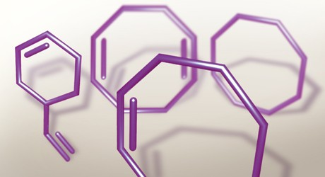

Caption: Special rings: Evonik offers the four most important C₈ monomers 1,5-cyclooctadiene (COD), cyclooctene (COE), cyclooctane (COAN), and 4-vinylcyclohex-1-ene (VCH).

About Resource Efficiency
The Resource Efficiency segment is led by Evonik Resource Efficiency GmbH and supplies high performance materials for environmentally friendly as well as energy-efficient systems to the automotive, paints & coatings, adhesives, construction, and many other industries. This segment employed about 8,600 employees, and generated sales of around €4.3 billion in 2015.

About Evonik
Evonik, the creative industrial group from Germany, is one of the world leaders
in specialty chemicals. Profitable growth and a sustained increase in the value of the company form the heart of Evonik’s corporate strategy. Its activities focus on the key megatrends health, nutrition, resource efficiency and globalization. Evonik benefits specifically from its innovative prowess and integrated technology platforms.

Evonik is active in over 100 countries around the world. In fiscal 2015 more than 33,500 employees generated sales of around €13.5 billion and an operating profit (adjusted EBITDA) of about €2.47 billion.

Disclaimer
In so far as forecasts or expectations are expressed in this press release or where our statements concern the future, these forecasts, expectations or statements may involve known or unknown risks and uncertainties. Actual results or developments may vary, depending on changes in the operating environment. Neither Evonik Industries AG nor its group companies assume an obligation to update the forecasts, expectations or statements contained in this release.

