May 31, 2016
Contact person press
Evonik Resource Efficiency GmbH
Thomas Lange
Market Communications
Phone +49 201 173-3050
thomas.lange2@evonik.com
Evonik Resource Efficiency GmbH
Rellinghauser Straße 1-11
45128 Essen
Phone +49 201 177-01
Fax +49 201 177-3475
www.evonik.com/iXsenic
www.iXsenic.com

Supervisory Board
Dr. Ralph Sven Kaufmann, Chairman

Executive Board
Dr. Claus Rettig, Chairman
Dr. Johannes Ohmer,
Simone Hildmann,
Alexandra Schwarz

Registered Office: Essen
Register Court: Essen Local Court
Commercial Registry B 25783
VAT ID no. DE 815528487

CPT and Evonik jointly present LCD display with solution-type metal oxide semiconductor iXsenic® inside on this year’s Display Week

During Display Week trade fair in San Francisco German specialty chemical company Evonik Industries and Taiwanese display maker Chunghwa Picture Tubes (CPT) have given a joint presentation to show an enhanced LCD display with iXsenic® metal oxide semiconductor inside.

iXsenic® is a solution-processable inorganic metal oxide semiconductor for the display industry supplied by the Resource Efficiency segment of Evonik. It is applied under ambient conditions: no vacuum environment is needed which results in process simplifications, high yield and cost advantages. iXsenic® is best applied via slot-die coating.

The Taiwanese display maker Chunghwa Picture Tubes (CPT) is dedicated to offer full-sized product line and position itself as a leader for visual telecommunication products and the all-around innovator for optronic technology.

After CPT’s demo display presentation last year on Touch Taiwan CPT and Evonik have again joined forces to apply the iXsenic® metal oxide semiconductor on CPT’s Gen4 mass production line. The result – a 5.8 inch mobile phone display with higher performance and reliability – was now shown on SID’s Display Week.

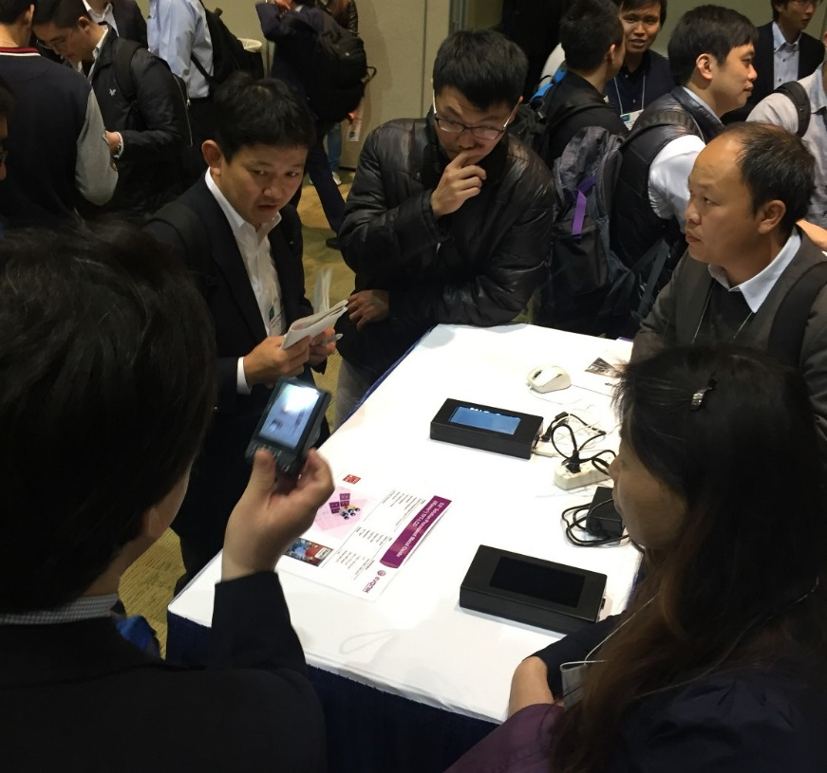

Caption: Joint author interview of CPT and Evonik at SID 2016

“It’s a great honor to present our progress on the Display Week which is one of the most important trade fairs for the display industry in the world,” says Prof. Ralf Anselmann, Vice President Electronic Solutions at Evonik. “And we are proud to do it together with our partner, display maker Chunghwa Picture Tubes.”

“With this display we have again shown the mass production suitability of iXsenic® in the coating process,” comments Dr. Jang-Jeng Liang, CTO at CPT. “And we are improving - we are now constantly moving closer towards mass production.”

Besides the demo display presentation Evonik had another appearance at the Display Week fair: Together with SCREEN FT Evonik presented first results of their strategic partnership and gave an outlook for the future: It was stated that both companies will offer a mass manufacturing solution for metal oxide semiconductor technology iXsenic® until 2017.

For further information please visit our websites www.iXsenic.com
and www.iXsenic.com.cn (Mandarin).

About Resource Efficiency
The Resource Efficiency segment is led by Evonik Resource Efficiency GmbH and supplies high performance materials for environmentally friendly as well as energy-efficient systems to the automotive, paints & coatings, adhesives, construction, and many other industries. This segment employed about 8,600 employees, and generated sales of around €4.3 billion in 2015.

About Evonik
Evonik, the creative industrial group from Germany, is one of the world leaders in specialty chemicals. Profitable growth and a sustained increase in the value of the company form the heart of Evonik’s corporate strategy. Its activities focus on the key megatrends health, nutrition, resource efficiency and globalization. Evonik benefits specifically from its innovative prowess and integrated technology platforms.

Evonik is active in over 100 countries around the world. In fiscal 2015 more than
33,500 employees generated sales of around €13.5 billion and an operating profit
(adjusted EBITDA) of about €2.47 billion.

Disclaimer
In so far as forecasts or expectations are expressed in this press release or where our statements concern the future, these forecasts, expectations or statements may involve known or unknown risks and uncertainties. Actual results or developments may vary, depending on changes in the operating environment. Neither Evonik Industries AG nor its group companies assume an obligation to update the forecasts, expectations or statements contained in this release.

