June 1, 2016
Specialized Press Contact Europe
Thomas Lange
Coating Additives
Phone+49 201 173 3050
thomas.lange2@evonik.com

Specialized Press Contact
Americas
Jacek Gediga
Coating Additives
Phone+1 804 727 0670
jacek.gediga@evonik.com

Specialized Press Contact Asia
Ariel Fang
Phone +86 21 6119 1505
ariel.fang@evonik.com

Evonik Resource Efficiency GmbH
Rellinghauser Straße 1-11
45128 Essen
Germany
Phone +49 201 177-01
Telefax +49 201 177-3475
www.evonik.de

Executive Board
Dr. Claus Rettig, Chairman
Dr. Johannes Ohmer, Simone Hildmann, Alexandra Schwarz

Registered Office: Essen
Registered Court: Essen Local Court
Commercial Registry B 25783
VAT ID no. DE 815528487

Evonik expands its additive portfolio for radiation-curing printing inks and varnishes

Evonik’s TEGO® Rad 2800 is a new release additive for printing inks and varnishes. The new product displays the highest release effect in our Rad portfolio and thus takes a further step in completing the range of radiation-curing glide and release additives. TEGO® Rad 2800 has pronounced silicone character, combining strong hydrophobing properties with optimum system compatibility.

The Rad portfolio from Evonik is unique because the additives can be crosslinked into the coating; the resulting glide and release effects are particularly durable. With conventional additives, the release effect is markedly weaker and less permanent because the additives are not bound into the coating.

The use of TEGO® Rad 2200 N, 2250, and 2300 allows formulators to achieve good glide and flow in print varnishes, resulting in defined surface smoothness and good haptic qualities. Because of their outstanding compatibility, their use does not impair transparency.

TEGO® Rad 2500, 2650, and 2800 distinguish themselves particularly by their good release effect, so adhesive strips can be easily detached without leaving a residue.

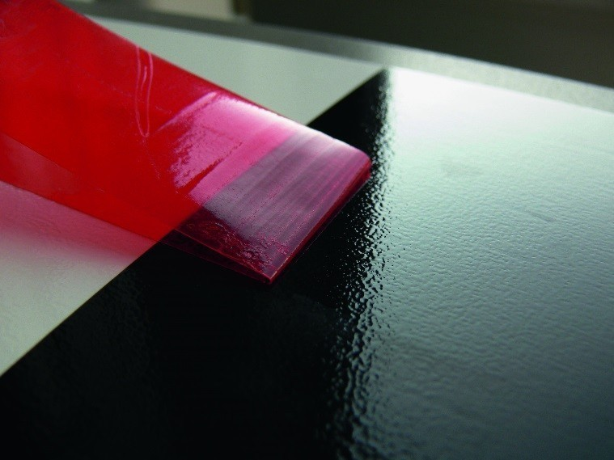

Image: Release Test

About Resource Efficiency
The Resource Efficiency segment is led by Evonik Resource Efficiency GmbH and supplies high performance materials for environmentally friendly as well as energy-efficient systems to the automotive, paints & coatings, adhesives, construction, and many other industries. This segment employed about 8,600 employees, and generated sales of around €4.3 billion in 2015.

Company information
Evonik, the creative industrial group from Germany, is one of the world leaders
in specialty chemicals. Profitable growth and a sustained increase in the value of the company form the heart of Evonik’s corporate strategy. Its activities focus on the key megatrends health, nutrition, resource efficiency and globalization. Evonik benefits specifically from its innovative prowess and integrated technology platforms.

Evonik is active in over 100 countries around the world. In fiscal 2015 more than 33,500 employees generated sales of around €13.5 billion and an operating profit (adjusted EBITDA) of about €2.47 billion.

Disclaimer
In so far as forecasts or expectations are expressed in this press release or where our statements concern the future, these forecasts, expectations or statements may involve known or unknown risks and uncertainties. Actual results or developments may vary, depending on changes in the operating environment. Neither Evonik Industries AG nor its group companies assume an obligation to update the forecasts, expectations or statements contained in this release.

