October 18, 2016

Contact person specialized press
Horst-Oliver Buchholz
Performance Materials
Communication
Phone +49 6181 59-13149
Fax +49 6181 59-713149
horst-oliver.buchholz@evonik.com

Evonik Performance
Materials GmbH
Rellinghauser Straße 1-11
45128 Essen
Germany
Phone +49 201 177-01
Fax +49 201 177-3475
www.evonik.com

Managing Directors
Johann-Caspar Gammelin, Chairman
Dr. Michael Pack,
Magdalena Wagner,
Rainer Wobbe

Registered Office Essen
Register Court
City Local Court Essen
Commercial Registry B 25779
Apples and yogurt can now stay fresh longer: Evonik improves food packaging

- Evonik's 1,7-Octadiene approved for use in food packaging
- European Food Safety Authority confirms product safety
- Minimum additive, maximum effect: Crosslinker improves the properties of plastic products

Essen. Packaging made of plastic keeps food such as fruit and dairy products fresh and safe to eat. Crosslinkers from Evonik ensure that the packaging remains stable for a long time. The European Food Safety Authority has now approved the crosslinker 1,7-Octadiene (FCM - Substance No. 1034) for specific plastics which come into contact with food. This is valid for use in long-term packaging at room temperature and also for hot-filling, the authority announced recently in the update of annex I for Regulation (EU) No. 10/2011.

“The requirements for packaging, in particular for perishable food, are growing constantly. With 1,7-Octadiene, we support our customers in meeting these requirements and we enable them to further optimize their packaging. In addition, the successful approval confirms the diverse application possibilities for our product,” says Dr. Frank Kraushaar, head of the Polymer Additives Market Segment at Evonik.

Chemical crosslinkers improve the properties of polymers by linking the polymer strands to a three-dimensional, stable structure. 1,7-Octadiene is used as a crosslinker for a range of polymers, principally polyolefins (PE and PP). The properties of the plastics can be improved significantly by linking them with even a small amount of 1,7-Octadiene (< 1 percent): One of the effects is that the polymer can be processed faster and/or the melt viscosity is improved. Also, packaging manufactured from these plastics is chemically, thermally and mechanically more stable. This could result in longer lifecycles or reduced material input.

In addition to 1,7-Octadiene, Evonik offers its customers a wide range of chemical crosslinkers. Additives such as TAICROS® and TAICROS®M enable electron-beam crosslinking of polyamide and thus ensure an improvement in the properties of the material.

Evonik will present these and other special monomers and additives at the K 2016 trade show in Düsseldorf from October 19 to 26, 2016. Hall 6/Stand B28.

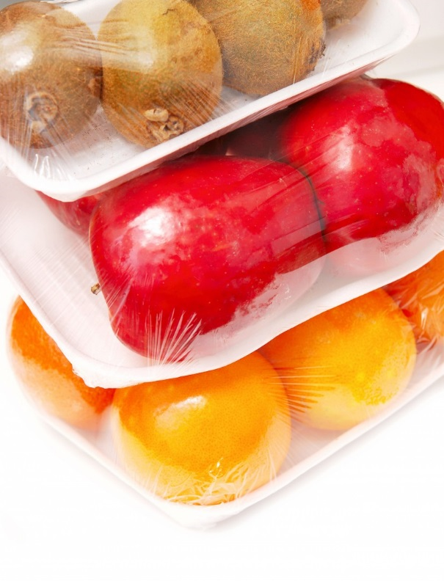

Caption:
1,7-Octadiene has been approved as a crosslinker for food – and can now be used to improve the material properties of plastic film for packaging of apples (Source: istock Essentials/Daniya Melnikova).

Company information
Evonik, the creative industrial group from Germany, is one of the world leaders in specialty chemicals, operating in the Nutrition & Care, Resource Efficiency and Performance Materials segments. The company benefits from its innovative prowess and integrated technology platforms. In 2015 more than 33,500 employees generated sales of around €13.5 billion and an operating profit (adjusted EBITDA) of about €2.47 billion.

About Performance Materials
The Performance Materials Segment is managed by Evonik Performance Materials GmbH. The segment focuses its global activities on developing and manufacturing polymer materials and intermediates, especially for use in agriculture and in the rubber and plastics industry. In 2015, the segment’s roughly 4,400 employees generated sales about €3.4 billion.

Disclaimer
In so far as forecasts or expectations are expressed in this press release or where our statements concern the future, these forecasts, expectations or statements may involve known or unknown risks and uncertainties. Actual results or developments may vary, depending on changes in the operating environment. Neither Evonik Industries AG nor its group companies assume an obligation to update the forecasts, expectations or statements contained in this release.

