July 30, 2015
Economic press contact
Silke Linneweber
Corporate Press
Phone +49 201 177-3389
Fax +49 201 177-3030
silke.linneweber@evonik.com
Specialized press contact
Lisa Dierks
Head of Communications / Personal Care
Phone +49 201 173-3170
Fax +49 201 173-713170
lisa.dierks@evonik.com
Evonik Industries AG
Rellinghauser Straße 1-11
45128 Essen
Germany
Phone +49 201 177-01
Telefax +49 201 177-3475
www.evonik.com

Supervisory Board
Dr. Werner Müller, Chairman

Executive Board
Dr. Klaus Engel, Chairman
Dr. Ralph Sven Kaufmann
Christian Kullmann
Thomas Wessel
Ute Wolf
Registered office Essen
Registered court
Essen local court
Commercial registry B 19474
VAT ID no. DE 811160003

Evonik globalizes research & development for the cosmetic industry

- Innovation centers opened in South Africa and Singapore
- New hair laboratory in Brazil
- Local research & development strengthens the position of Evonik in important growth markets

Essen. Evonik is driving the internationalization of its research & development (R&D) for the cosmetic industry forward. “Evonik is one of the world's leading manufacturers of products and active ingredients for the cosmetic industry. The distinctly expanded global structure of Innovation Management strengthens our
position as strategic partner of our customers close to their local markets and thus supports profitable growth,” says Hans-Josef Ritzert, managing director of Evonik Nutrition & Care GmbH.

The company recently opened innovation centers in Midrand (South Africa) and Singapore, which develop product solutions in the area of personal care for customers in the Sub-Saharan Africa region and in Southeast Asia, Australia, and New Zealand. The new facilities supplement the worldwide network of laboratories of Evonik's cosmetic business, which also includes sites in Essen, Guarulhos (Brazil), Hopewell (USA), and Shanghai (China). Evonik has just added a hair laboratory to the applications laboratory that has existed in Guarulhos/Brazil since 2012, in order to support its customers in Central and South America in the development of innovative hair care products. More than one hundred employees worldwide work in research & development for the cosmetic industry. In the past years, Evonik has put new large-scale plants for the production of active ingredients for the cosmetics industry into operation in China and Brazil. With this, the company is also active in these attractive growth markets and can serve local and regional customers from a local base even better.

Custom-tailored innovative products for customers

“In body and hair care, the requirements of consumers upon personal care products vary widely around the world. In response, we provide custom-tailored solutions, which we develop right at the local site with determination and scientific excellence,” says Tammo Boinowitz, head of the Personal Care business at Evonik. For instance, women in Brazil often wash their hair twice a day and therefore need more care. Particularly popular are conditioners with regenerative effects, which are not washed out after application. In contrast, in Europe, consumers prefer products of light consistence that are rinsed out.

Cosmetic products: Attractive growth market

With around five percent per year the market for cosmetic products is growing faster worldwide than the global gross domestic product. In Brazil alone, the demand has risen steadily in recent years by about 10 percent. The main driver in emerging economies is the growth of a middle class with strong purchasing power. At the same time, consumers worldwide are increasingly seeking high-quality products that are custom-tailored to their needs. For instance, Evonik has developed a body lotion formula for the South American market that releases moisture when applied – so that it simultaneously nourishes and refreshes.

Evonik is a specialist in the care and cleaning of skin and hair. As a supplier of high-quality raw materials, the Personal Care Business Line serves all the large cosmetic enterprises around the world. Among other things, the products include emulsifiers, surfactants, active substances, conditioners, thickeners, and emollients. In the end products, the raw materials from Evonik make a decisive contribution to their consistency, effect, and sensory impression.

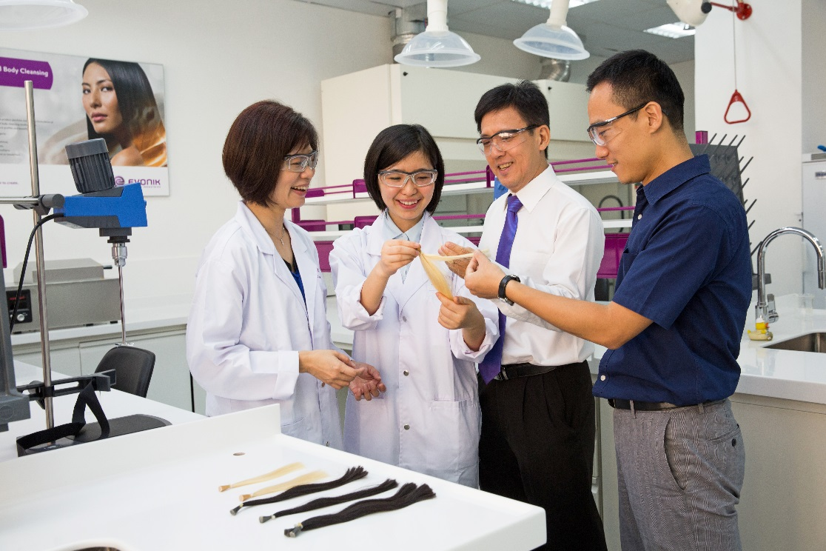
Capture: Evonik is driving the internationalization of its research & development (R&D) for the cosmetic industry forward. The company recently opened innovation centers in Midrand (South Africa) and Singapore.

Company information
Evonik, the creative industrial group from Germany, is one of the world leaders
in specialty chemicals. Profitable growth and a sustained increase in the value of the company form the heart of Evonik’s corporate strategy. Its activities focus on the key megatrends health, nutrition, resource efficiency and globalization. Evonik benefits specifically from its innovative prowess and integrated technology platforms.

Evonik is active in over 100 countries around the world. In fiscal 2014 more than 33,000 employees generated sales of around €12.9 billion and an operating profit (adjusted EBITDA) of about €1.9 billion.

Disclaimer
In so far as forecasts or expectations are expressed in this press release or where our statements concern the future, these forecasts, expectations or statements may involve known or unknown risks and uncertainties. Actual results or developments may vary, depending on changes in the operating environment. Neither Evonik Industries AG nor its group companies assume an obligation to update the forecasts, expectations or statements contained in this release.

