October 19, 2015
Economic press contact
Silke Linneweber
Corporate Press
Phone +49 201 177-3389
Fax +49 301 177-3053
silke.linneweber@evonik.com

Evonik Industries AG
Rellinghauser Straße 1-11
45128 Essen
Germany
Phone +49 201 177-01
Telefax +49 201 177-3475
www.evonik.de

Supervisory Board
Dr. Werner Müller, Chairman

Executive Board
Dr. Klaus Engel, Chairman
Dr. Ralph Sven Kaufmann
Christian Kullmann
Thomas Wessel
Ute Wolf
Registered office Essen
Registered court
Essen local court
Commercial registry B 19474
VAT ID no. DE 811160003

Innovative pipelines for offshore production:
Evonik invests in Airborne Oil & Gas

- Direct investment in Dutch company by Evonik’s venture capital arm
- Non-corrosive pipelines made of thermoplastic composites for offshore oil & gas
- Broadening of Evonik’s expertise for the oil & gas industry

Essen. Through its venture capital arm, Evonik has invested in Airborne Oil & Gas (IJmuiden, Netherlands). The specialty chemicals group now holds a minority interest in the Dutch company. The investment was made jointly with HPE Growth Capital (HPE) and Shell Technology Ventures. The parties have agreed not to disclose the volume of the transaction. Airborne Oil & Gas (AOG) possesses a unique technology for the production of thermoplastic composite pipes for a variety of offshore oil and gas applications.

The current offshore oil & gas infrastructure consists of either rigid steel pipes or so-called flexibles. The latter comprise of multiple layers of steel and polymers. AOG’s thermoplastic composite pipes dispense with steel entirely and are therefore not susceptible to corrosion. They have extremely high mechanical stability but are also flexible. As an added advantage they are lightweight and can be fabricated in lengths of up to 10 kilometers, which means that AOG’s pipes can be installed relatively simply and cost effectively. Rigid steel lines are welded together from segments that are 10-20 meters long, using highly specialized and costly pipelaying vessels.

AOG’s thermoplastic composite pipes are suitable and beneficial for a wide range of offshore applications. A number of operators have qualified AOG’s pipes for offshore oil & gas transport lines, where the benefits of low cost installation and the absence of corrosion offer breakthrough improvements. A considerable amount of the 150,000 to 200,000 km of globally installed transport lines is over 20 years old and in need of replacement, which is an attractive entry point for AOG.

For Evonik, the oil & gas industry is an attractive growth market and an important innovation field. Furthermore, the company is a market leader in polyamide 12, marketed as VESTAMID®, which is well-proven in pipes for oil and gas production and transport “Airborne Oil & Gas is an excellent strategic match for Evonik,” says Bernhard Mohr, head of Venture Capital at Evonik. “Their unique pipe technology and Evonik's high performance polymer portfolio enable us to develop new solutions for the industry.

“In Evonik we’ve gained a strategic investor with an extensive knowledge of plastics for oil & gas applications,” says Eric van der Meer, CEO of AOG. “We hope this will give us additional impetus to develop our business further.”

Excellent mechanical properties thanks to unidirectional tapes
AOG’s pipelines consist of three layers: An inner plastic pipe is covered with a composite of unidirectional tapes, which in turn is sheathed by plastic. Polymers such as polyethylene, polypropylene, polyamide 12 and PEEK can be used. Unidirectional tapes are thin plastic bands in which continuous reinforcing fibers are embedded in parallel alignment. When a number of such bands are stacked vertically at defined angles and fused together, it results in an extremely stable composite.

AOG’s special expertise lies in the design of both the composite material and the finished pipe, for a variety of applications: All the layers are melt-fused to one another inseparably, which explains the outstanding mechanical properties of the pipelines. AOG is therefore regarded as an innovation leader in thermoplastic composite pipelines for oil & gas applications.

As part of its venture capital activities, Evonik plans to invest a total of €100 million in promising start-ups with innovative technologies and in leading specialized venture capital funds. The regional focus is on Europe, the US, and Asia. Evonik currently has holdings in seven start-ups and three funds. Further information is available at http://venturing.evonik.com/

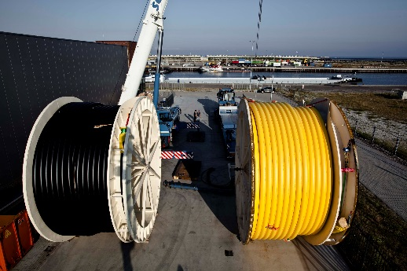

Capture:
AOG Flowlines ready for shipment to a customer

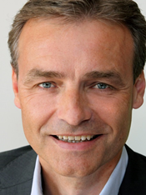

Capture:
Eric van der Meer, CEO of Airborne Oil & Gas

Company information
Evonik, the creative industrial group from Germany, is one of the world leaders
in specialty chemicals. Profitable growth and a sustained increase in the value of the company form the heart of Evonik’s corporate strategy. Its activities focus on the key megatrends health, nutrition, resource efficiency and globalization. Evonik benefits specifically from its innovative prowess and integrated technology platforms.

Evonik is active in over 100 countries around the world. In fiscal 2014 more than 33,000 employees generated sales of around €12.9 billion and an operating profit (adjusted EBITDA) of about €1.9 billion.

Disclaimer
In so far as forecasts or expectations are expressed in this press release or where our statements concern the future, these forecasts, expectations or statements may involve known or unknown risks and uncertainties. Actual results or developments may vary, depending on changes in the operating environment. Neither Evonik Industries AG nor its group companies assume an obligation to update the forecasts, expectations or statements contained in this release.

