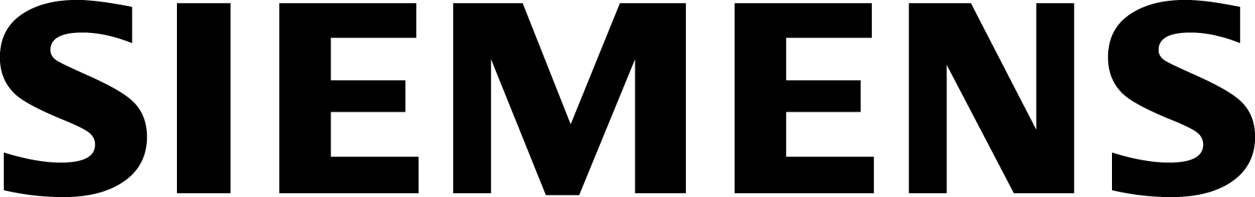
June 27, 2013
Evonik Industries AG contact:
Alexandra Boy
Deputy Press Officer, Corporate Press
T +49 201 177-3167
F +49 201 177-3030
alexandra.boy@evonik.com
E.ON SE contact:
Alexander Ihl
Political Affairs and Corporate Communications
Regional External Communications
T +49 211 4579-368
F +49 211 4579-529
alexander.ihl@eon.com

E.ON and Evonik ensure Marl Chemical Park’s energy supply

- Evonik to replace old generating unit with a new combined-cycle gas turbine plant to be built by E.ON

To ensure the energy supply to Marl Chemical Park, Evonik’s largest production facility, contracts were signed yesterday to build a new combined-cycle gas turbine (CCGT) power plant. The plant is a joint project of Evonik and E.ON. Siemens will supply the CCGT.
Siemens AG contact:
Christian Stuart Wilson
Business Press for Siemens’s Fossil Power Generation/Oil & Gas divisions
Telefon: +49 9131 18-4974
christian_stuart.wilson@siemens.com

Marl Chemical Park currently receives electricity and steam from three power plants consisting of a total of five generating units. The oldest of these is unit 3, which in a few years will reach the end of its useful operating life. Unit 3 will be replaced with a new CCGT plant with 60 megawatts (MW) of electric capacity. E.ON will build the new plant at a central location at Evonik’s production facility; the plant is expected to enter service in 2015. Switching from coal to gas will enable Evonik to reduce its carbon emissions at Marl by about 280,000 metric tons annually.

Evonik will control and have operational and legal responsibility for the power plant once it is in service. E.ON will plan, finance, and build the new Marl plant and provide a number of services related to its operation. E.ON Energy Projects, the E.ON subsidiary that will build the plant, has installed, or played a key role in installing, 1,600 MW of electric capacity.

“The new CCGT will be an important step toward updating Marl Chemicals Park’s power and steam supply,” said Caspar Gammelin, President Site Services at Evonik. “In view of E.ON’s well-earned reputation for new-build expertise, we’re pleased to have them as a partner in our joint project.” The new plant will ensure that Marl Chemical Park has a reliable and cost-effective supply of power and heat well into the future.

“The construction of a new CCGT at Marl Chemical Park is another example of how E.ON is systematically propelling the expansion of distributed generation in Germany and doing so in a customer-

oriented manner,” said Ingo Luge, CEO of E.ON Deutschland. He added that “distributed generation is an important aspect of the transformation of Germany’s energy system, to which we intend to make a substantial contribution.”

“For Siemens, receiving the order to supply key components to the new Marl power plant is confirmation that we’re able to provide our customers with sustainable products to update their energy supply,” said Markus Tacke, CEO of Siemens Energy’s Industrial Power business unit. “Combining an SGT-800 gas turbine and an SST-300 steam turbine is a proven solution. Together they create a state-of-the-art CCGT that optimally meets today’s requirements for operational flexibility and reliable performance over the long term. The gas turbine generates electricity extremely efficiently and economically.” Siemens was also awarded a multi-year service contract to maintain the gas turbine and ensure that it meets high standards for performance, availability, and reliability.

Disclaimer
In so far as forecasts or expectations are expressed in this press release or where our statements concern the future, these forecasts, expectations or statements may involve known or unknown risks and uncertainties. Actual results or developments may vary, depending on changes in the operating environment. Neither Evonik Industries AG nor its group companies assume an obligation to update the forecasts, expectations or statements contained in this release.

