Friedrich Bergius – chemist, pioneering researcher and Nobel Prize laureate

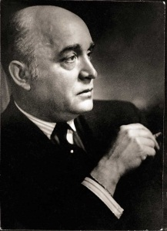
Friedrich Bergius (born 1884 in Goldschmieden, Silesia; died 1949 in Buenos Aires) was a chemist and Nobel Prize laureate. He worked for one of the predecessor companies of Evonik from 1914 to 1918, including as a member of the executive board of Th. Goldschmidt AG from 1916 to 1918. In 1931, Friedrich Bergius received the Nobel Prize for Chemistry jointly with Carl Bosch "in recognition of their contributions to the invention and development of chemical high-pressure methods." Thanks to his pioneering basic research, Friedrich Bergius is now considered one of the most important German chemists of the 20th century. His research continues to influence some of the chemicals produced at Evonik to this day.
Friedrich Bergius

Bergius began his studies of chemistry in Breslau in 1903 and completed his doctoral studies in Leipzig in 1907. Reflecting the influence of Nobel laureate Fritz Haber, his professorial thesis was entitled "Application of high pressure in chemical processes and simulation of the genesis of coal." Written at the dawn of the automotive and aerospace age, Bergius’ work turned out to be prescient. He believed to have found a way to "liquidize" the rich coal deposits in Germany under high pressure to turn them into gasoline.

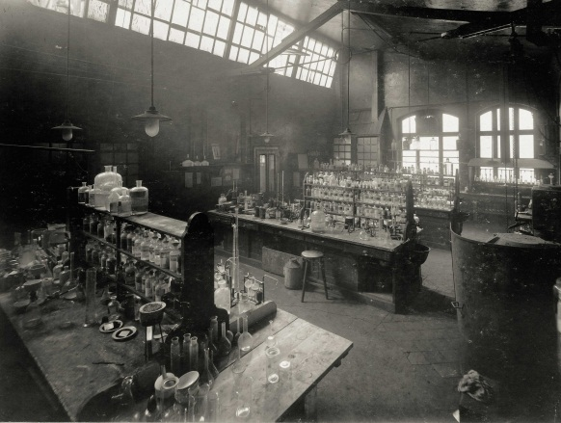
Since Karl Goldschmidt, the chairman of the Th. Goldschmidt AG executive board, shared the conviction that gasoline would dominate the future, he provided Bergius with the means to implement his findings on an industrial scale. In 1913, Bergius therefore came to Essen, where he was appointed the head of research in a new, specially built laboratory and advanced to deputy member of the executive board of Th. Goldschmidt AG in 1916. Given the urgency of World War I, large-scale tests began in 1916 at the Mannheim-Rheinau plant to quickly bring the liquefaction of coal to serial production. However, the tests did not yield the desired success as quickly as expected and Bergius' employment ultimately came to an end in 1918. It would take until the 1930s for the large-scale implementation of coal liquefaction to succeed at the well-endowed I.G. Farben-Konzern, which received enormous subsidies from the Nazi government to make coal gasoline a reality.
Bergius laboratory, inside view 1914

The scientific inquisitiveness of the scientist, who died in 1949 in Buenos Aires, continues to benefit the Group to this day. Although Bergius had never been able to make profitable use of the his insights in ethylene chemistry during his time as a research manager, his successor Hans Schrader began to develop promising products in 1927. These included the first emulsifier, which is still known under the brand name Tegin®. Emulsifiers are essential for developing emulsions containing oil and water because it is difficult to combine the individual components.

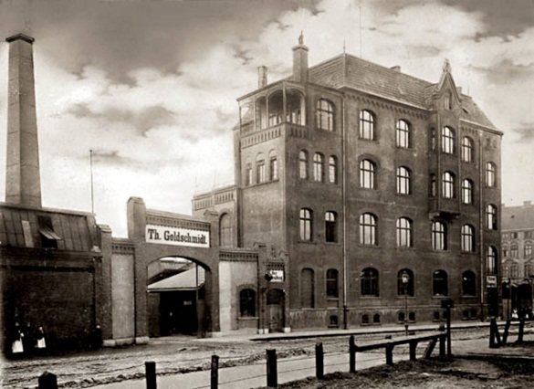
Nowadays, the emulsifiers of Evonik Industries form the basis for the Personal Care Business Line and are used in a wide range of applications. These include a number of care products for daily use such as sun screen, anti-wrinkle cream or body lotion.

The plant on Goldschmidtstraße in Essen continues to be an important production site of Evonik, exactly in the place where construction started on a new chemical plant 125 years ago. One year beforehand, Karl Goldschmidt and his brother Hans had decided to move the company seat from Berlin to Essen. Today, some 1,600 employees research, develop, and produce ingredients for the cosmetics industry, specialty chemicals for coatings and paints, coatings for labels and adhesive tape as well as stabilizers for foam production at the site.
Goldschmidt Essen plant, main administrative building around 1900

