January 14, 2016
Economic press contact
Silke Linneweber
Corporate Press
Phone +49 201 177-3389
Fax +49 301 177-3053
silke.linneweber@evonik.com

Specialized press contact
Stefan Cornelissen
Head of Communication
Corporate Innovation
Phone +49 201 177-4327
Fax +49 201 177-4322
stefan.cornelissen@evonik.com
Evonik Industries AG
Rellinghauser Straße 1-11
45128 Essen
Germany
Phone +49 201 177-01
Telefax +49 201 177-3475
www.evonik.de

Supervisory Board
Dr. Werner Müller, Chairman

Executive Board
Dr. Klaus Engel, Chairman
Dr. Ralph Sven Kaufmann
Christian Kullmann
Thomas Wessel
Ute Wolf
Registered office Essen
Registered court
Essen local court
Commercial registry B 19474
VAT ID no. DE 811160003

Evonik expands venture capital activities into Asia

- Evonik is investing in Chinese venture capital fund GRC SinoGreen Fund III
- GRC focuses on material-related start-ups from
Greater China
- Evonik now has access to one of the most important, rapidly growing venture capital regions

Essen. By investing in the Chinese venture capital fund GRC SinoGreen Fund III (GRC III), Evonik has expanded its venture capital activities into Asia. The parties have agreed to not disclose the amount of the investment. As a result, the company is now represented in the most important venture capital regions of North America, Europe, and Asia. GRC invests in private, green technology companies with unique strengths and substantial growth potential in Greater China. Target sectors include energy and resource efficiency, cleaner transportation, sustainability, and climate change mitigation and adaptation. GRC III has offices in Beijing and Taipei. In recent years, Asia has evolved into the world’s third-most important venture capital region. China accounts for around two-thirds of these activities.

“By investing in GRC III, we are opening the door to the fast growing start-up community in Greater China,” explained Bernhard Mohr, head of Venture Capital at Evonik. “With GRC we have found a strong partner with a proven track record and with immediate relevance to our own business activities.” Aside from Evonik, the investor base of GRC III includes the World Bank subsidiary International Finance Corporation, the development bank Netherlands Development Finance Company (FMO) and Shell Technology Ventures, the venture capital arm of Shell. “We would like to welcome our new investor” said Eric Wang, general partner of GRC. “With Evonik, we have added an important strategic partner to our investor base.”

Investments in funds are an important element of Evonik’s venture capital activities. Previously, Evonik had invested in the European and North American venture capital funds Pangaea Ventures Fund III, Emerald Cleantech Fund III, and High-Tech Gründerfonds II.
“The collaboration with venture capital funds and innovative start-ups complements our open innovation strategy and creates excellent opportunities for accelerating the development of new businesses and opening up new growth fields,” said Mohr.

As part of its venture capital activities, Evonik plans to invest a total of €100 million in promising start-ups with innovative technologies and in leading specialized venture capital funds. The regional focus is on Europe, the US, and Asia. Evonik currently has holdings in eight start-ups and four funds. Further information is available at http://venturing.evonik.com/

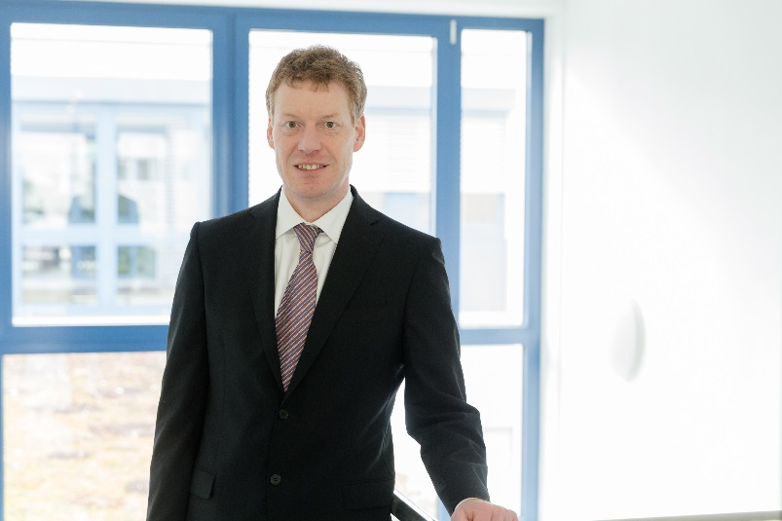

Capture: Bernhard Mohr, head of Venture Capital at Evonik

Company information
Evonik, the creative industrial group from Germany, is one of the world leaders
in specialty chemicals. Profitable growth and a sustained increase in the value of the company form the heart of Evonik’s corporate strategy. Its activities focus on the key megatrends health, nutrition, resource efficiency and globalization. Evonik benefits specifically from its innovative prowess and integrated technology platforms.

Evonik is active in over 100 countries around the world. In fiscal 2014 more than 33,000 employees generated sales of around €12.9 billion and an operating profit (adjusted EBITDA) of about €1.9 billion.

Disclaimer
In so far as forecasts or expectations are expressed in this press release or where our statements concern the future, these forecasts, expectations or statements may involve known or unknown risks and uncertainties. Actual results or developments may vary, depending on changes in the operating environment. Neither Evonik Industries AG nor its group companies assume an obligation to update the forecasts, expectations or statements contained in this release.

