September 10, 2014
Contact person economic press
Dr. Edda Schulze
Corporate Press
Phone +49 201 177-2225
Fax +49 201 177-3030
edda.schulze@evonik.com
Contact person specialized press
Frank Gmach
Communication Inorganic Materials
Telephone +49 6181 59-13588
Fax +49 6181 59-713588
frank.gmach@evonik.com
Evonik Industries AG
Rellinghauser Straße 1-11
45128 Essen
Germany
Phone +49 201 177-01
Telefax +49 201 177-3475
www.evonik.de

Supervisory Board
Dr. Werner Müller, Chairman
Executive Board
Dr. Klaus Engel, Chairman
Christian Kullmann
Thomas Wessel
Patrik Wohlhauser
Ute Wolf

Registered office Essen
Registered court
Essen local court
Commercial registry B 19474
VAT ID no. DE 811160003

Evonik Completes Precipitated Silica Expansion In Chester, Pennsylvania

Demand For Fuel-Efficient Tires Driving Capacity Increase

CHESTER, Pa., September 9, 2014 – Evonik Corporation today opened a new 20,000 metric ton expansion at its precipitated silica site in Chester, Pa.

“This is a very exciting day,” said Andreas Fischer, Head of Evonik’s Silica Business Line. “Chester is an integral part of Evonik’s global silica business. We have expanded our plants and constructed new facilities in Asia and Europe, and now we’ve built up our capacities for precipitated silicas in North America as well.”

Fischer explained the capacity addition in Chester was part of Evonik’s initiative to increase world-wide capacities for precipitated silica by 30 percent since 2010.

“Demand for precipitated silica is increasing,” said Fischer. “Our expansion in Chester will enable us to keep pace with the growth of our customers and to meet the requirements of the tire, food and other industries. Our dedicated employees in Chester and at our other sites throughout the world have enabled Evonik to remain a market leader in silica.”

One of the major uses of precipitated silica is the automotive sector, said David Elliott, site manager at Evonik’s Chester facility. “Our products are used to manufacture fuel-efficient tires which significantly reduce the rolling-resistance of tires and achieve considerable fuel savings compared with conventional car tires. Fuel efficient tires help to cut fuel consumption by upwards of 8 percent,” said Elliott.

Precipitated silica is also used as an ingredient in the food and animal feed industries, as well as in paints and coatings.

In July, Evonik announced plans to build a plant to produce precipitated silica outside São Paulo, Brazil. The facility is scheduled to go on stream in 2016. The increased development in North and South America follows expansions that have already been completed in Europe and Asia. A production plant extension was completed in Thailand in March 2014.

Evonik is one of the leading producers of silica. In addition to precipitated silica, Evonik also produces the fumed silica AEROSIL® and silica-based matting agents under the ACEMATT® brand.

Evonik has a worldwide capacity of about 550,000 metric tons of precipitated and fumed silica and matting agents per year.

For additional information about Evonik in North America, please visit our website: www.evonik.com/north-america

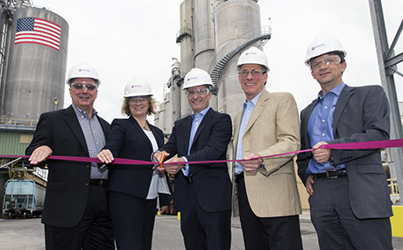

Caption:
Representatives of Evonik from North America and Germany open the new plant (from left): Arthur Dube (Silica Business Line North America), Heidi Grön (Global Head of Production Inorganic Materials), Andreas Fischer (Head of the Silica Business Line), David Elliot (Site Manager, Chester) and Rainer Hahn (Head of the Silica Business Line in NAFTA)

Company information
Evonik, the creative industrial group from Germany, is one of the world leaders
in specialty chemicals. Profitable growth and a sustained increase in the value of the company form the heart of Evonik’s corporate strategy. Its activities focus on the key megatrends health, nutrition, resource efficiency and globalization. Evonik benefits specifically from its innovative prowess and integrated technology platforms.

Evonik is active in over 100 countries around the world. In fiscal 2013 more than 33,500 employees generated sales of around €12.7 billion and an operating profit (adjusted EBITDA) of about €2.0 billion.

Disclaimer
In so far as forecasts or expectations are expressed in this press release or where our statements concern the future, these forecasts, expectations or statements may involve known or unknown risks and uncertainties. Actual results or developments may vary, depending on changes in the operating environment. Neither Evonik Industries AG nor its group companies assume an obligation to update the forecasts, expectations or statements contained in this release.

