March 8, 2017

Matthias Ruch
Head of External Communications
Evonik Industries AG
Phone +49 201 177-3348
matthias.ruch@evonik.com
Herman Betten
Head of Communications

DSM Nutritional Products
Phone +31 45 5782017
herman.betten@dsm.com

Evonik Industries AG
Rellinghauser Straße 1-11
45128 Essen
Germany
Phone +49 201 177-01
Fax +49 201 177-3475
www.evonik.com

Supervisory Board
Dr. Werner Müller, Chairman
Executive Board
Dr. Klaus Engel, Chairman
Christian Kullmann, Deputy Chairman
Dr. Ralph Sven Kaufmann
Thomas Wessel
Ute Wolf

Registered Office is Essen
Register Court Essen Local Court
Commercial Registry B 19474

Press Release

DSM and Evonik establish joint venture for omega-3 fatty acids from natural marine algae for animal nutrition

- Breakthrough for animal nutrition to reduce impact on ocean resources and making it more sustainable
- Commercial-scale facility for algal oil for salmon aquaculture and pet food to be built in the United States
- Further develop and produce a high value algal oil with a natural balance of EPA and DHA

Essen (Germany), Kaiseraugst (Switzerland). Royal DSM and Evonik today announced their intention to establish a joint venture for omega-3 fatty acid products from natural marine algae for animal nutrition. This breakthrough innovation will, for the first time, enable the production of omega-3 fatty acids for animal nutrition without using fish oil from wild caught fish, a finite resource. Evonik and DSM’s alternative omega-3 source is the first to offer both EPA and DHA and will be aimed at initial applications in salmon aquaculture and pet food. The companies will together build a commercial-scale production facility in the United States.

DSM Nutritional Products and Evonik Nutrition & Care will each hold a 50% share in the joint venture and co-own the production facility, which will be built at an existing site of Evonik and is expected to come on stream in 2019. The joint venture plans to invest around US$ 200 million in the facility (USD 100 million by each party over circa 2 years). The initial annual production capacity will meet roughly 15% of the total current annual demand for EPA and DHA by the salmon aquaculture industry. The set-up of the joint venture, to be named Veramaris and headquartered in The Netherlands, will be finalized subject to regulatory approvals and other customary closing conditions.

Evonik’s and DSM’s highly concentrated algal oil is a high value and pure source that will enable the animal nutrition industry to keep up with the increasing demand for these two essential omega-3 fatty acids without endangering fish stocks, contributing to healthy animal nutrition as well as to the ecological balance and biodiversity of the oceans.

Joint development between DSM and Evonik
The joint venture follows the joint development agreement, signed in July 2015. Under this agreement, Evonik and DSM have jointly worked on the development of products and the manufacturing process and explored opportunities for commercialization. Both companies achieved positive results in the development of the product while extensively working with the entire value chain, including fish feed producers, fish farmers and retailers.

Under the joint development agreement, DSM and Evonik have successfully produced pilot-scale quantities of the algal oil at DSM’s production facility in Kingstree, South Carolina (United States). Customers will be able to receive sizeable quantities of the product for market development while the construction of the new manufacturing plant is underway.

The successful product and process development was only possible thanks to the complementary competencies that Evonik and DSM bring to the collaboration: DSM has expertise in the cultivation of marine organisms including algae and long-established biotechnology capabilities in development and operations, whilst Evonik’s focus has been on developing industrial biotechnology processes and operating competitively large-scale manufacturing sites for fermentative amino acids.

Innovation breakthrough for aquaculture, pet food and beyond
The algal oil from DSM and Evonik means that the vision of salmon farming without using fish-based resources is – for the first time – becoming realistic. By replacing fish oil in salmon feed with this EPA and DHA rich alternative, the fish-in-fish-out ratio could be reduced significantly. This alternative will enable the aquaculture industry to continue to grow sustainably.

Worldwide fish oil production is approximately one million metric tons per year. Most of the fish oil is used in aquaculture, mainly for fat-rich fish species, such as salmon. The limited wild fish stocks restrict the amount of fish oil available and thus the growth of the aquaculture industry. Currently, the industry uses about 75% of the annual production of fish oil. Evonik and DSM’s algal oil will offer a sustainable non-fish alternative.

Just like humans, animals also need their daily intake of essential, long-chain polyunsaturated fatty acids in their diet to ensure healthy growth. Until now, these fatty acids have been added to aquaculture feed and pet food almost exclusively from marine sources such as fish oil and fishmeal. As the new algal oil can be applied in feed production in the same way as fish oil, it can easily be introduced by feed and pet food producers.

DSM and Evonik are also pursuing applications of their algal oil for other aquatic and terrestrial animal species.

Omega-3 fatty acids EPA and DHA
Omega-3 fatty acids are a family of polyunsaturated fats, including eicosapentaenoic acid (EPA) and docosahexaenoic acid (DHA). Because they are not produced naturally by the body, omega-3s must be obtained from the diet or through supplementation. A large and growing body of evidence shows that sufficient levels of omega-3 EPA and DHA support brain, eye and heart health in multiple species, including humans.

Research suggests that omega-3 EPA and DHA may lower triglyceride levels (lipids) in the blood and may have positive effects on arterial function. Eating seafood twice a week is recommended by multiple health authorities. In a study evaluating the risks and benefits of fish intake published in the Journal of the American Medical Association JAMA, researchers found that 1-2 servings of fish per week, especially fish high in omega-3 EPA and DHA, reduced the risk of coronary death by 36% and total mortality by 17%.

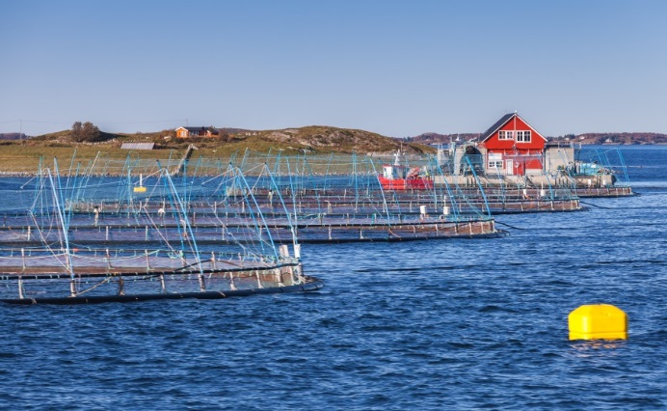
Norwegian fish farm in a fjord near Trondheim, Norway.
© shutterstock / Evannovostro

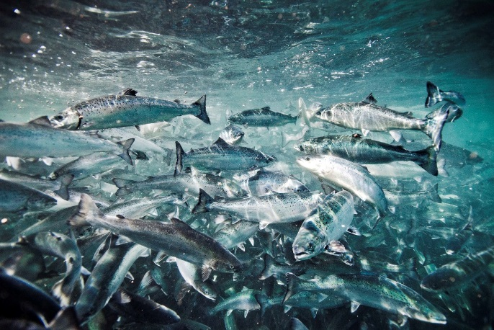

Atlantic salmon (salmo salar) in aquafarm.
© DSM

Pets take up essential nutrients such as omega-3
fatty acids through pet food.
© shutterstock / Jaromir Chalabala

About Evonik
Evonik, the creative industrial group from Germany, is one of the world leaders in specialty chemicals. Profitable growth and a sustained increase in the value of the company form the heart of Evonik’s corporate strategy. Its activities focus on the key megatrends health, nutrition, resource efficiency and globalization. Evonik benefits specifically from its innovative prowess and integrated technology platforms. Evonik is active in over 100 countries around the world with more than 35,000 employees. In fiscal 2016 the enterprise generated sales of around €12.7 billion and an operating profit (adjusted EBITDA) of about €2,165 billion.

About Evonik Nutrition & Care
The Nutrition & Care segment is led by Evonik Nutrition & Care GmbH and contributes to fulfilling essential human needs. That includes applications for everyday consumer goods as well as animal nutrition and health care. This segment employed about 7,500 employees, and generated sales of around €4.3 billion in 2016.

DSM – Bright Science. Brighter Living.™
Royal DSM is a global science-based company active in health, nutrition and materials. By connecting its unique competences in Life Sciences and Materials Sciences DSM is driving economic prosperity, environmental progress and social advances to create sustainable value for all stakeholders simultaneously. DSM delivers innovative solutions that nourish, protect and improve performance in global markets such as food and dietary supplements, personal care, feed, medical devices, automotive, paints, electrical and electronics, life protection, alternative energy and bio-based materials. DSM and its associated companies deliver annual net sales of about €10 billion with approximately 25,000 employees. The company is listed on Euronext Amsterdam. More information can be found at www.dsm.com.

Disclaimer Evonik
In so far as forecasts or expectations are expressed in this press release or where our statements concern the future, these forecasts, expectations or statements may involve known or unknown risks and uncertainties. Actual results or developments may vary, depending on changes in the operating environment. Neither Evonik Industries AG nor its group companies assume an obligation to update the forecasts, expectations or statements contained in this release.

Forward-looking statements DSM
This press release may contain forward-looking statements with respect to DSM’s future (financial) performance and position. Such statements are based on current expectations, estimates and projections of DSM and information currently available to the company. DSM cautions readers that such statements involve certain risks and uncertainties that are difficult to predict and therefore it should be understood that many factors can cause actual performance and position to differ materially from these statements. DSM has no obligation to update the statements contained in this press release, unless required by law. The English language version of the press release is leading.

