February 10, 2016

Contact person economic press
Edda Schulze
Corporate press
Phone +49 201 177-2225
Fax +49 201 177-3030
edda.schulze@evonik.com

Contact person Specialized Press
Janusz Berger
High Performance Polymers
Phone 49 2365 49-9227
Fax +49 2365 49-809878
janusz.berger@evonik.com

Evonik Industries AG
Rellinghauser Straße 1-11
45128 Essen
Germany
Phone +49 201 177-01
Fax +49 201 177-3475
www.evonik.com

Supervisory Board
Dr. Werner Müller, Chairman
Executive Board
Dr. Klaus Engel, Chairman
Dr. Ralph Sven Kaufmann
Christian Kullmann
Thomas Wessel
Ute Wolf

Registered office Essen
Registered court
Essen local court
Commercial registry B 19474
VAT ID no. DE 811160003
Evonik to expand capacity for VESTOSINT® polyamide 12 powder in Marl

- Evonik to expand its leading position in powdered polyamide 12
- Strong growth potential, especially in 3D printing
- Investment volume in the mid double-digit million euro range
- New facility to become operational in late 2017

Essen/Marl. Evonik Industries plans to build a new production line for special polyamide 12 powder (PA12) in Marl (Germany) with an investment volume in the mid double-digit million euro range. The new plant, which is scheduled to become operational in late 2017, will increase the Group’s existing annual capacity for polyamide 12 powders by 50 percent.

“The planned investment in the new polyamide 12 powder facility represents the next step in our growth strategy. Our intention is to solidify Evonik’s leading position as a provider of polyamide 12-based high performance polymers and utilize the growth potential of new application areas,” said Dr. Ralph Sven Kaufmann, Chief Operating Officer of Evonik.

The Resource Efficiency Segment of Evonik is the market leader for polyamide 12 powders, which are sold under the brand name VESTOSINT®. The powders are used, for example, to coat metals for household appliances such as dishwasher baskets, but also in automotive and medical technology production and as matting and structural agents in coatings. Evonik also anticipates significant increases in demand in tool-free production–especially in the 3D printing industry. “We project attractive market growth. The new production line in Marl will meet the growing demand for PA12 powder products in the long term to support our customers’ growth,” said Dr. Claus Rettig, the Chairman of the Board of Management of Evonik Resource Efficiency GmbH.

Due to their mechanical properties and chemical resistance as well as the high melting point of finished products, PA12 powders are particularly suitable for use in powder-based 3D printing processes such as selective laser sintering (SLS) and high-speed sintering (HSS). Fiber composite materials represent another growth field. Polyamide 12 powders are an ideal matrix for thermoplastic composites made of fiberglass, carbon fibers, and aramid or steel fibers. Applications can be found in the automotive and oil drilling industry, the sports sector and in orthopedics.

VESTOSINT® is a modified PA12 powder that is manufactured at the Marl site from a polyamide granulate, using a proprietary Evonik process.

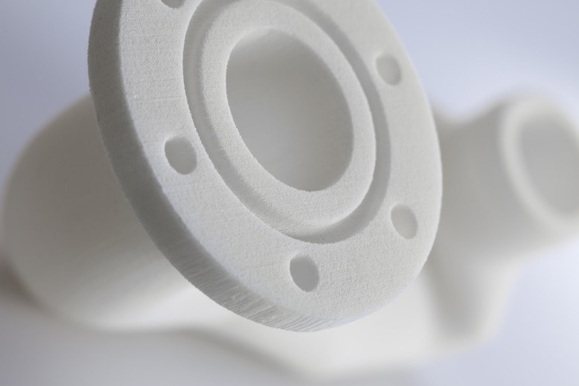

Capture: Air duct component for an engine compartment, manufactured with the use of a 3D printing process and VESTOSINT®.

Company information
Evonik, the creative industrial group from Germany, is one of the world leaders
in specialty chemicals. Profitable growth and a sustained increase in the value of the company form the heart of Evonik’s corporate strategy. Its activities focus on the key megatrends health, nutrition, resource efficiency and globalization. Evonik benefits specifically from its innovative prowess and integrated technology platforms.
Evonik is active in over 100 countries around the world. In fiscal 2014 more than 33,000 employees generated sales of around €12.9 billion and an operating profit (adjusted EBITDA) of about €1.9 billion.

About Resource Efficiency
The Resource Efficiency segment is led by Evonik Resource Efficiency GmbH and supplies high performance materials for environmentally friendly as well as energy-efficient systems to the automotive, paints & coatings, adhesives, construction, and many other industries. This segment employed about 7,800 employees, and generated sales of around €4 billion in 2014.

Disclaimer
In so far as forecasts or expectations are expressed in this press release or where our statements concern the future, these forecasts, expectations or statements may involve known or unknown risks and uncertainties. Actual results or developments may vary, depending on changes in the operating environment. Neither Evonik Industries AG nor its group companies assume an obligation to update the forecasts, expectations or statements contained in this release.

