September 12, 2017

Constanze Buckow-Wallén
Marketing & Communication
Region Europe
Phone +49 6181 59-12566
Mobile +49 152 09379905
constanze.buckow-wallen@evonik.com

Evonik Industries AG
Rellinghauser Straße 1-11
45128 Essen
Germany
Phone +49 201 177-01
Fax +49 201 177-3475
www.evonik.com

Supervisory Board
Dr. Werner Müller, Chairman
Executive Board
Christian Kullmann, Chairman
Dr. Harald Schwager, Deputy Chairman
Thomas Wessel
Ute Wolf

Registered Office is Essen
Register Court Essen Local Court
Commercial Registry B 19474
Matthias Hau is the new Regional President Eastern Europe
and Head of the Unit Sites Europe at Evonik

Hanau. Matthias Hau has taken on the responsibility for the further development of the business in the Eastern European markets as well as the management of overarching aspects for the sites all over Europe as president of the Eastern European Region as of September 1, 2017. He succeeds Thomas Müller, who has been leading the activities of the European Region since 2011 and retired.
Matthias Hau joined Evonik in 1982 while completing a vocational training at the former Degussa AG, followed by a commercial trainee program in Germany and England. After working as a sales employee in Melbourne (Australia), he was delegated to Singapore and Malaysia. Afterwards he held various responsibilities in sales, product management, and marketing, before he took over as head of the BioActives Business Unit. In 2005 he became the president of the India Region. After being head of the Agrochemicals & Polymer Additives Business Line at Performance Materials, he became responsible in 2016 for a sales programme across the group.

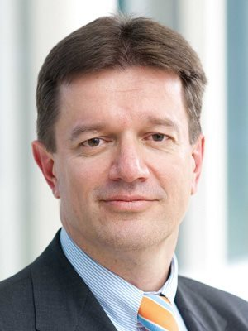

Company information
Evonik is one of the world leaders in specialty chemicals. The focus on more specialty businesses, customer-orientated innovative prowess and a trustful and performance-oriented corporate culture form the heart of Evonik’s corporate strategy. They are the lever for profitable growth and a sustained increase in the value of the company. Evonik benefits specifically from its customer proximity and leading market positions. Evonik is active in over 100 countries around the world with more than 35,000 employees. In fiscal 2016, the enterprise generated sales of around €12.7 billion and an operating profit (adjusted EBITDA) of about €2.165 billion.

Disclaimer
In so far as forecasts or expectations are expressed in this press release or where our statements concern the future, these forecasts, expectations or statements may involve known or unknown risks and uncertainties. Actual results or developments may vary, depending on changes in the operating environment. Neither Evonik Industries AG nor its group companies assume an obligation to update the forecasts, expectations or statements contained in this release.

