October 19, 2016
Economic press contact
Alexandra Boy
External Communications
Phone +49 201 177-3167
Fax +49 201 177-3030 alexandra.boy@evonik.com

alexandra.boy@evonik.com
Specialized press contact
Dr. Jürgen Krauter
Head of Communication
Nutrition & Care
Phone +49 6181 59-6847
Fax +49 6181 59-76847
juergen.krauter@evonik.com
Evonik Industries AG
Rellinghauser Straße 1-11
45128 Essen
Germany
Phone +49 201 177-01
Fax +49 201 177-3475
www.evonik.com

Supervisory Board
Dr. Werner Müller, Chairman

Executive Board
Dr. Klaus Engel, Chairman
Christian Kullmann, Deputy Chairman
Dr. Ralph Sven Kaufmann
Thomas Wessel
Ute Wolf

Registered office Essen
Registered court
Essen local court
Commercial Registry B 19474
VAT ID no. DE 811160003

Evonik starts construction of second methionine complex in Singapore

- DL-methionine in continued demand for animal nutrition
- Investment of more than half a billion euros
- Doubling the production capacity in Singapore to 300,000 metric tons per year

Essen/Singapore. Evonik Industries plans to build a second world-scale plant for the production of the amino acid DL-methionine in Singapore are fully on schedule. The company marked the official start of construction with a symbolic ground-breaking ceremony today, officiated by Tharman Shanmugaratnam, Singapore Deputy Prime Minister & Coordinating Minister for Economic and Social Policies. The complex will have an annual production capacity of 150,000 metric tons and is expected to become operational in 2019, with investment costs of more than half a billion euros. Evonik sells DL-methionine under the brand name MetAMINO®.

“Our methionine complex, which came on-stream in late 2014 on Jurong Island, is a success story. This led to our decision to build a second plant next to it,” said Klaus Engel, the chairman of the Executive Board of Evonik Industries, in Singapore today. “The demand for MetAMINO® for animal nutrition is continuing to grow at a very fast rate in Asia." The new plant will not only produce methionine, but also all strategically important precursors to guarantee product quality and supply security.

“Singapore has proven an ideal location for supplying our Asian customers,” said Reiner Beste, chairman of the Board of Management of Evonik Nutrition & Care GmbH. The new complex will create more than 150 jobs at the location. “We are pleased to have such qualified personnel available to us in this country,” Beste continued.

The new production complex will increase Evonik’s annual capacity of MetAMINO® to a total of approximately 300,000 metric tons in Asia, and to approximately 730,000 metric tons worldwide. The specialty chemicals company produces the amino acid in its world-scale plants in Antwerp (Belgium), Wesseling/Cologne (Germany), Mobile (Alabama, USA), and Singapore.
DL-methionine is an essential amino acid, which must be absorbed through feed intake. As a feed additive, it contributes to the efficient, healthy and environmentally friendly nutrition of livestock, particularly poultry and swine. That makes it an important component of ensuring a sustainable animal protein supply for the world’s growing population.

Evonik has over 60 years of experience in the manufacture of essential amino acids and provides solutions for efficient and sustainable animal nutrition to customers in over one hundred countries. Evonik wants to make an even greater contribution to the efficiency of animal feed by supplementing its portfolio with innovative feed additives beyond amino acids in order to create additional value for its customers. Evonik’s products and services in the area of animal nutrition play a key role worldwide in the production of healthy and affordable food, while preserving natural resources and reducing the ecological footprint.

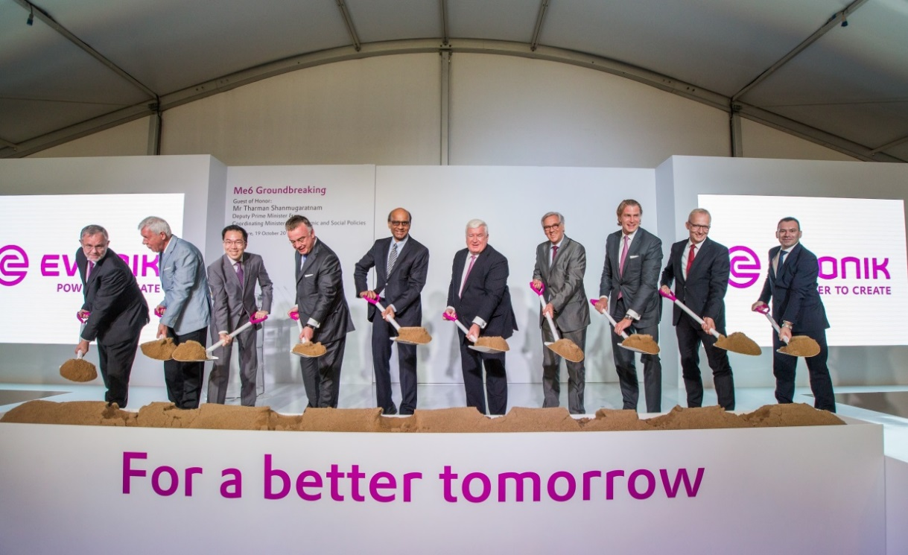

Caption:

Groundbreaking ceremony of Evonik’s Second Methionine Complex in Singapore (from left to right):

- Peter Meinshausen, Regional President of Evonik South East Asia, Australia & New Zealand
- Dr. Werner Mueller, Chairman of the Supervisory Board, Evonik Industries AG
- Dr. Beh Swan Gin, Chairman of the Singapore Economic Development Board
- Mr Christian Kullmann, Deputy Chairman of the Executive Board, Evonik Industries AG
- Mr Tharman Shanmugaratnam Deputy Prime Minister and Coordinating Minister for Economic and Social Policies
- Dr. Klaus Engel, Chairman of the Executive Board of Evonik Industries AG
- His Excellency Dr. Michael Witter, Ambassador of the Federal Republic of Germany to Singapore
- Dr. Ralph Sven Kaufmann, Chief Operating Officer, Evonik Industries AG
- Dr. Reiner Beste, Chairman of the Board, Management of Evonik Nutrition & Care GmbH
- Dr. Franck Furno, Project Director Evonik Me6, Evonik Nutrition & Care GmbH

Company information
Evonik, the creative industrial group from Germany, is one of the world leaders in specialty chemicals, operating in the Nutrition & Care, Resource Efficiency and Performance Materials segments. The company benefits from its innovative powers and integrated technology platforms. In 2015 more than 33,500 employees generated sales of around €13.5 billion and an operating profit (adjusted EBITDA) of about €2.47 billion.

About Nutrition & Care
The Nutrition & Care segment is led by Evonik Nutrition & Care GmbH and contributes to fulfilling basic human needs. That includes applications for everyday consumer goods as well as animal nutrition and health care. This segment employed about 7,000 employees, and generated sales of around
€4.9 billion in 2015.

Disclaimer
In so far as forecasts or expectations are expressed in this press release or where our statements concern the future, these forecasts, expectations or statements may involve known or unknown risks and uncertainties. Actual results or developments may vary, depending on changes in the operating environment. Neither Evonik Industries AG nor its group companies assume an obligation to update the forecasts, expectations or statements contained in this release.

